Costume update
I will post as more decisions are made. Most of the costumes are provided but when we need things like shoes, socks, or specific color shirts (that you might have at home ) it’s easier to ask for you to provide.

Who’s
Please wear white “ked” like shoes. Who girls, please purchase the solid color of tights listed below. I have given you 2 different colors to choose from. I know sometimes it’s hard to find certain colors in specific sizes. They need to be somewhat thick so they last all 9 shows. The tights you are buying are NOT the color of your dress, so if your kiddo says “mommy my dress is yellow and I’m buying purple tights” she’s right Seuss is vibrant and mismatchy and fun. You will be amazed how it all comes together on stage!

Kennedy – Purple or Red
Addison – Yellow or Red
Anna – Blue or Purple
Avery - Yellow or Red
Gabrielle – Yellow or Red
Brooke – Blue or Purple
Evelyn – Red or Yellow
Jaden – Green or Purple
Marianna – come try on dress
Nikki – come try on dress
Eva – come try on dress
Marlane- come try on dress

David – needs long sleeve bright red t shirt
Justin – Needs long sleeve bright green tee shirt

Thing 1 – white ked like shoes
Thing 2 – white ked like shoes

Nools –
Alexis – black socks and black shoes
Ashira – Cream tights and ballet slippers
Constance – Black tights and black shoes
Hailey – Black tights and black shoes
Izzy – Cream or brown tights and brown shoes
Makenna – brown or black tights with matching shoes
Yakira – black tights and black shoes

Wicks –
You can be in black, tan or brown shoes. I know many of you are purchasing jazz shoes and that is perfectly acceptable and probably the easiest to dance in. You can get them online or at payless. I’m still trying to figure out pants. This is the look we are going for minus the suspenders. So they need to be brown pants. All your shirts are the same tan color, but the vests ties and hats are all a different shade of brown. Your pants can be different shades as well. You will also have brown tails that I will attach. Please start looking for brown pants. Thrift stores are great places to find things like this. No sweat pants or light colored kahki. More of like a cargo or loose fitting jean type that is an actual brown.

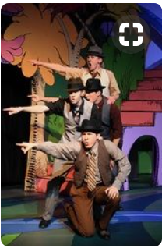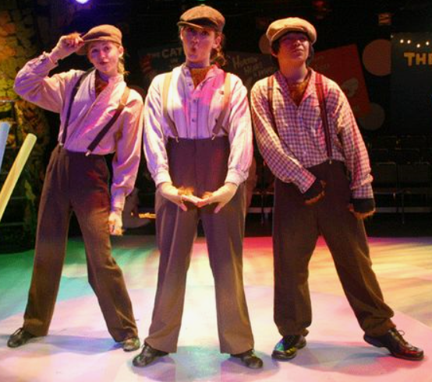

Horton – grey shoes
Jojo – converse
Cat- I’m thinking black converse but let’s look after I see you in the outfit this week.
Turtle/Grinch- black shoe
Gertrude – We need to look on stage with both your jazz and character shoe, but definitely tan.
Maize- We have the shoes you brought and are bedazzling them
Bird Girls – 1 to 1 ½ in character tan shoe
Elephant bird girl – Gabrielle- grey long sleeve and grey leggings. She can wear her white keds .
Vlad – black pants (slimmer fit) black shoes
General – Tan pants, brown shoes
Roo – ballet shoe
Fish – You need to be in all black, especially black long sleeve tee shirt. Wicks you can keep you brown pants on and change a black long sleeve tee
Twirlers – either tan character or tan jazz shoes

This will get things moving. I still need to work on Cadets, Hunches and circus crew, along with little things here or there. If you don’t see your name on this list, we either already have spoken or I haven’t got to that costume yet. 77 costumes and counting!!

Any questions… Ask Kelly two4kids@sbcglobal.net

